OpenHMIS Reporting Data Warehouse

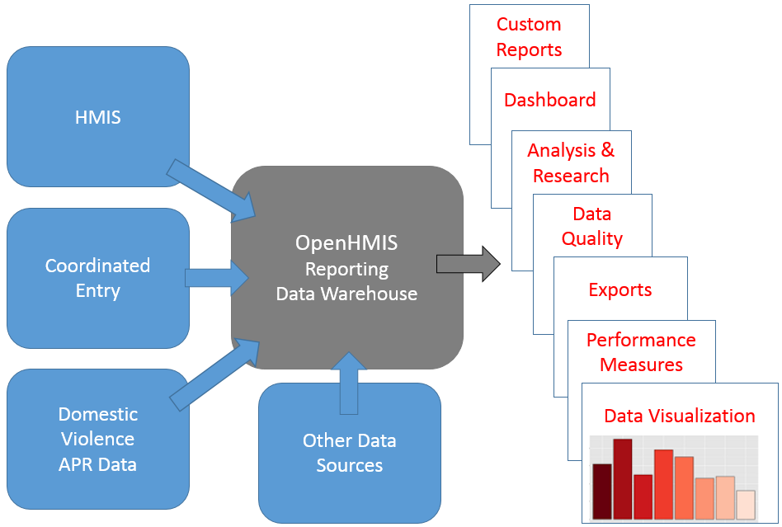

This project is intended to make Georgia’s HMIS data easily accessible for reporting, data visualization and data analysis. Our ultimate goal is to make HMIS production data available in real time for users, researchers, data analysts and stakeholders. Most of the development we are proposing has already been tested in prototypes using the latest in reporting software and data integration technologies. These technologies include, Application Programming Interface (API), Database Synchronization (MirrorSync), Cloud Servers, Open Source Software, Open Database Connectivity (ODBC), Java Database Connectivity (JDBC), as well as a variety of relational database management systems (RDBMS), reporting and data analysis software.

At the heart of the OpenHMIS Reporting Data Warehouse is a simplified database schema that uses Structured Query Language (SQL) to make data requests. The data tables and field names have been simplified so that non-programmers can easily find and access the data they are most interested in.

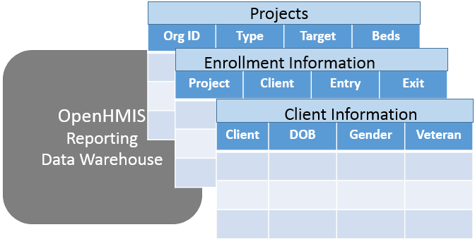

Georgia’s HMIS Reporting Data Warehouse was started several years ago when we implemented Open Database Connectivity (ODBC) which allowed users to connect to the database and access data using a variety of database and report writing software including Microsoft Access, Excel, and FileMaker. Soon data analysts began to connect using other reporting software such as R Programming and Shiny which allowed more powerful analytics and data visualization. Another database connector JDBC was added that allowed for faster and more powerful research projects.

**HMIS Data Analyst for Reporting and Data Visualization using R Programming and Shiny**

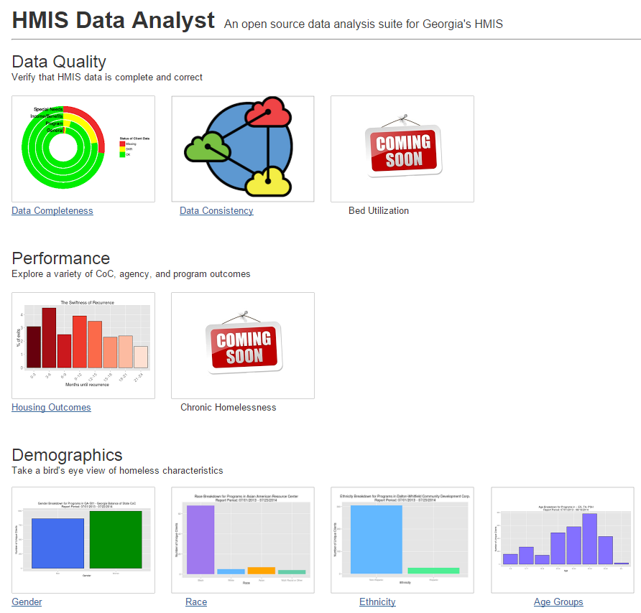

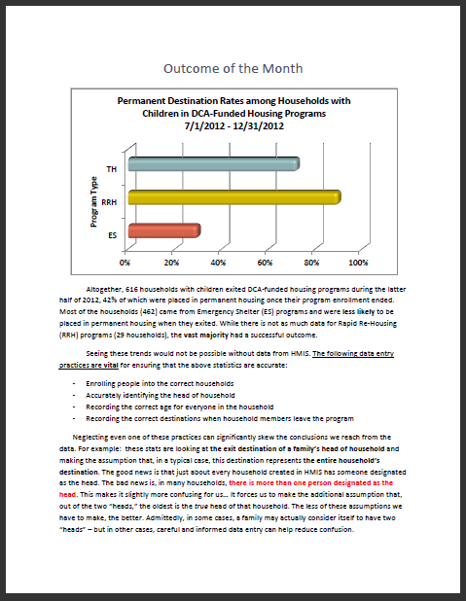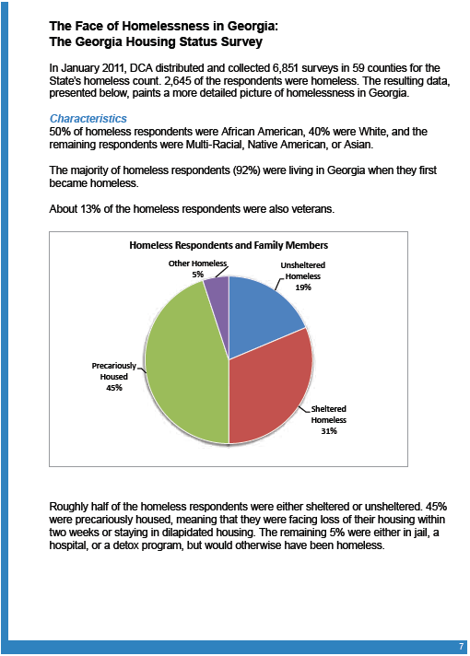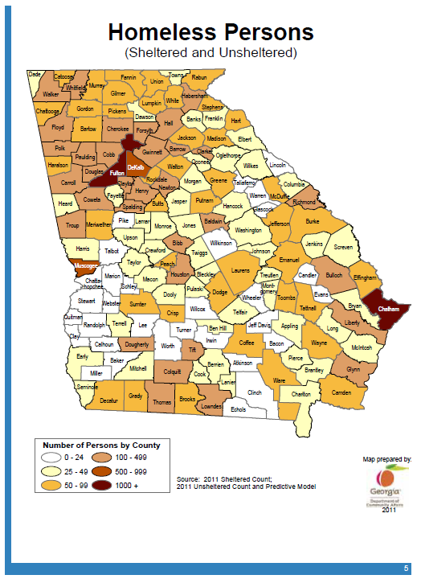

Logi-Analytics software was implemented to provide dashboard capability, simple custom report and chart building. The OpenHMIS reporting data warehouse has allowed data analysts and researchers to develop reports for demographics, data quality, outcomes and more advanced research such as performance measures and recidivism.

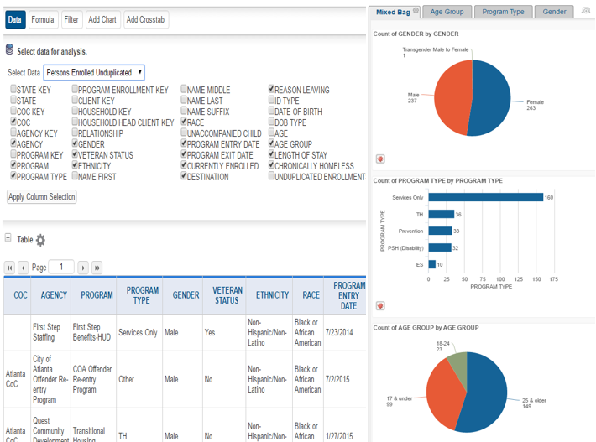

The current reporting data warehouse relies on a nightly data copy (sometimes referred to as a data dump) of our production data from Pathways Compass Rose. A new technology called MirrorSync by 360 Works was introduced and tested a means to synchronize the production data with the reporting data warehouse in order to replace the nightly data dump so that users can access production data in real time. When users enter or edit data in production HMIS, the data will automatically be updated in the HMIS Reporting Data Warehouse.

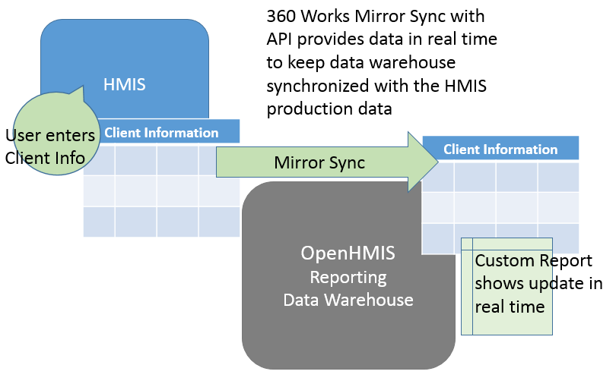

In the past when an agency performs data cleaning in Pathways Compass Rose in order to meet data quality requirements, agencies would need to wait one day for their reports to see if their data would be approved for reimbursement. With MirrorSync, the data cleaning improvements can be displayed immediately to verify data quality. The real time database synchronization with MirrorSync also offered a useful tool to integrate additional databases with the OpenHMIS Reporting Data Warehouse.

We have also introduced the OpenHMIS API (application programming interface) that allows third party software developers to enter data and access data directly from HMIS or the OpenHMIS Data Warehouse. We provide the endpoints (HUD required data elements) and programmers can make the connection directly between their applications and the HMIS data. The OpenHMIS API allows us to provide the important business rules we need to ensure HUD compliance. When the API is combined with MirrorSync data is validated before it is synchronized. Now data from a variety of sources can be made available in the Reporting Data Warehouse. These additional data sources might include Coordinated Entry Systems, Domestic Violence, DCA Grants Management System, State Agencies and even other HMIS software.

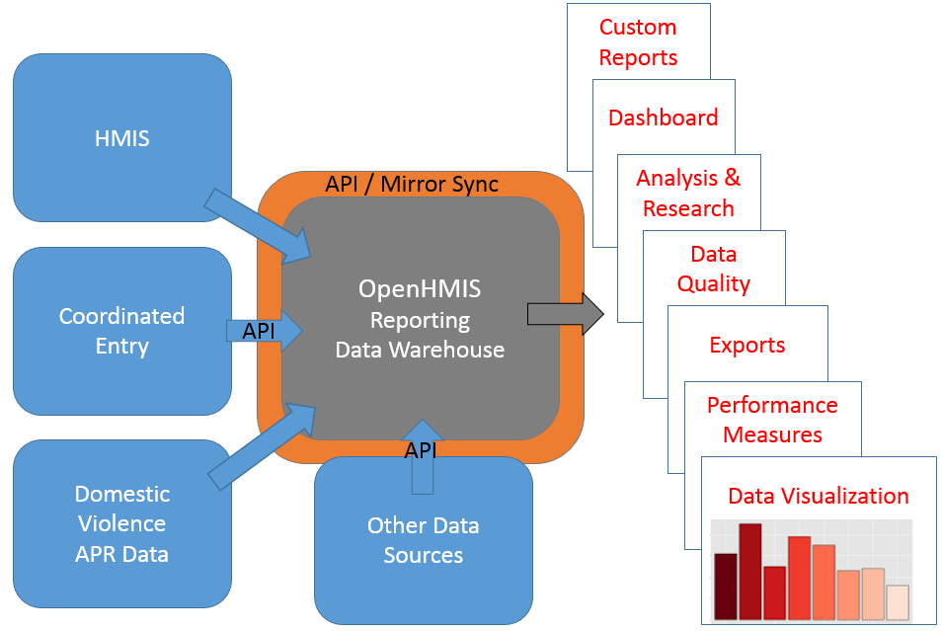

Our goal is to provide simpler access to data so that Users, Data Analysts, Researchers and Stakeholder have the Reports and Analytics they need to make better decisions in order to end homelessness. Even though much of this new technology has been tested and prototyped, there is still work to be done in order to leverage this technology and put this real time OpenHMIS Reporting Data Warehouse into production. The following proposal will outline the development required to make this happen.